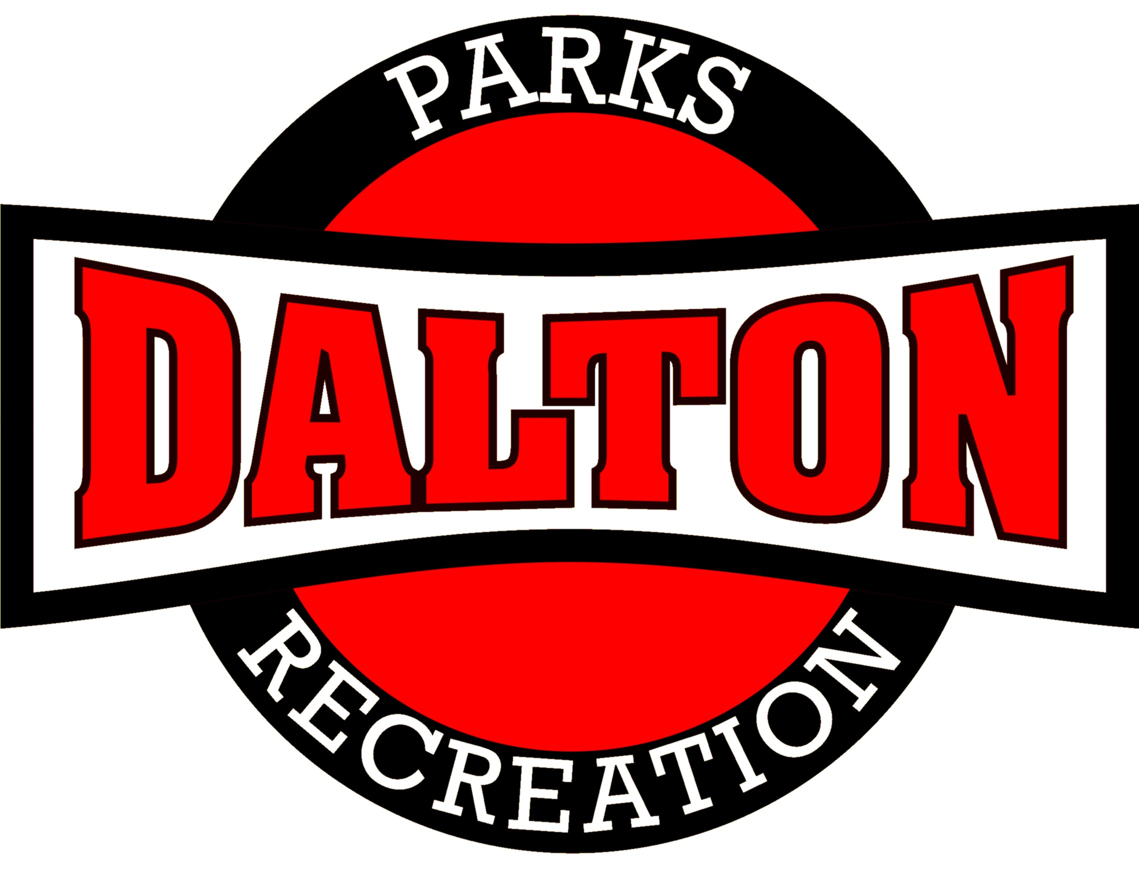

Dalton Parks and Recreation Department
706-278-5404
904 Civic Drive, Dalton, GA 30720
www.mydprd.com

Request For Proposal

Athletic Photography Services Contract

The Dalton Parks and Recreation Department is currently seeking Request for Proposal (RFP’s) from all interested, licensed & permitted suppliers for its Youth Athletics Photography Services. The awarded party will have a yearly renewable contract; good for three years.
Responsibilities of Partner: The organization or individual must provide the following:
- Work with the recreation staff to schedule team and individual picture days during each sports program.
- Provide sufficient staffing and equipment to complete all team and individual photos in a timely manner.
- Deliver picture day information forms to the Recreation Department for each individual player no later than 14 days prior to picture day. Hard copy or email form are both acceptable.
- Offer a variety of picture packages, including affordable options.
- Collect and account for all money paid for photo packages while offering a variety of methods of payment.
- Return all photos to the Recreation Department for distribution OR contractor may mail purchased photographs directly to players. Must be delivered within 2 weeks after the scheduled picture day.
- Provide all customers with clear, properly formatted, professional quality color prints.
- Resolve any problems associated with photo sessions or with the delivered products.
- Provide a report within 30 days of photography session showing the total sales generated from each photography session.
- Agree to pay Dalton Parks and Recreation a set commission rate of gross sales or a set amount for each package sold for each sport program’s photography session. This should be paid within 15 days to the generated total sales report.
Responsibilities of DPRD: Dalton Parks and Recreation will provide the following:
- DPRD will work with the contractor before each season start date to schedule a picture day.
- Provide adequate space to take photographs.
- Distribute picture day information forms to each player (as provided by the contractor).
- Distribute photographs to the individual players, if needed.
- DPRD will have a staff person on site to assist with flow of the picture day schedule.
Dalton Parks and Recreation Youth Sports Programs
Program | # of Teams  (average) | # of Players per Team  (Average) | Season
Basketball | 58 | 8 | December-February
Baseball | 33 | 12 | March-May
Softball | 13 | 12 | March-May
Soccer | 50 | 9 | March-May  September-October
Lacrosse | 2 | 15 | March-May
Volleyball | 20 | 8 | March-May  September-October
Track/Cross Country | 1 | 20 | March-May  September-October
Football (flag/tackle) | 4/4 | 8/22 | September-October
Cheerleading | 12 | 12 | September-October

Qualifications:
Each responding firm must provide proof of the following:
- Proof of valid operating business license.
- Name, address, and phone number of three references.
- Proof of providing similar services for similar sized programs.
- Proof of insurance, including: Business Liability (naming Dalton Parks and Recreation as Additional Insured).
The following conditions apply to this submission:

- List of three references including company name, contact person, address, phone number, and email address
- List three similar sized services you have provided in the past three years.
- Samples of pervious work including photo(s), registration form(s), list of package options and prices.
- Proof of liability insurance (Dalton City to be added once contract is awarded).
- Proof of valid business license.
- Statement indication the “percentage of Gross Sales” or the amount of “per Package Sold” to be returned to Dalton Parks and Recreation Department.
- It is the responsibility of the contractor to ensure all photos and merchandise be returned to individuals and teams. The Recreation Department will assist in distributing the merchandise to each team during the regular season however, in the event merchandise is not ready by the end of the season the contractor will be solely responsible to deliver the merchandise to the players.

Proposal Submittals

Proposal should be submitted to City of Dalton –Rhonda Sissom, Finance Department along with this completed and signed application of this RFP (Due Date: Wednesday, July 2, 2025 at 10:00am)

- Mail proposals to: City of Dalton, Rhonda Sissom
- Attention: Dalton Parks and Recreation Department – Sports Photography Proposal
- 300 W Waugh St, Dalton, GA 30720
Request For Proposal Application

