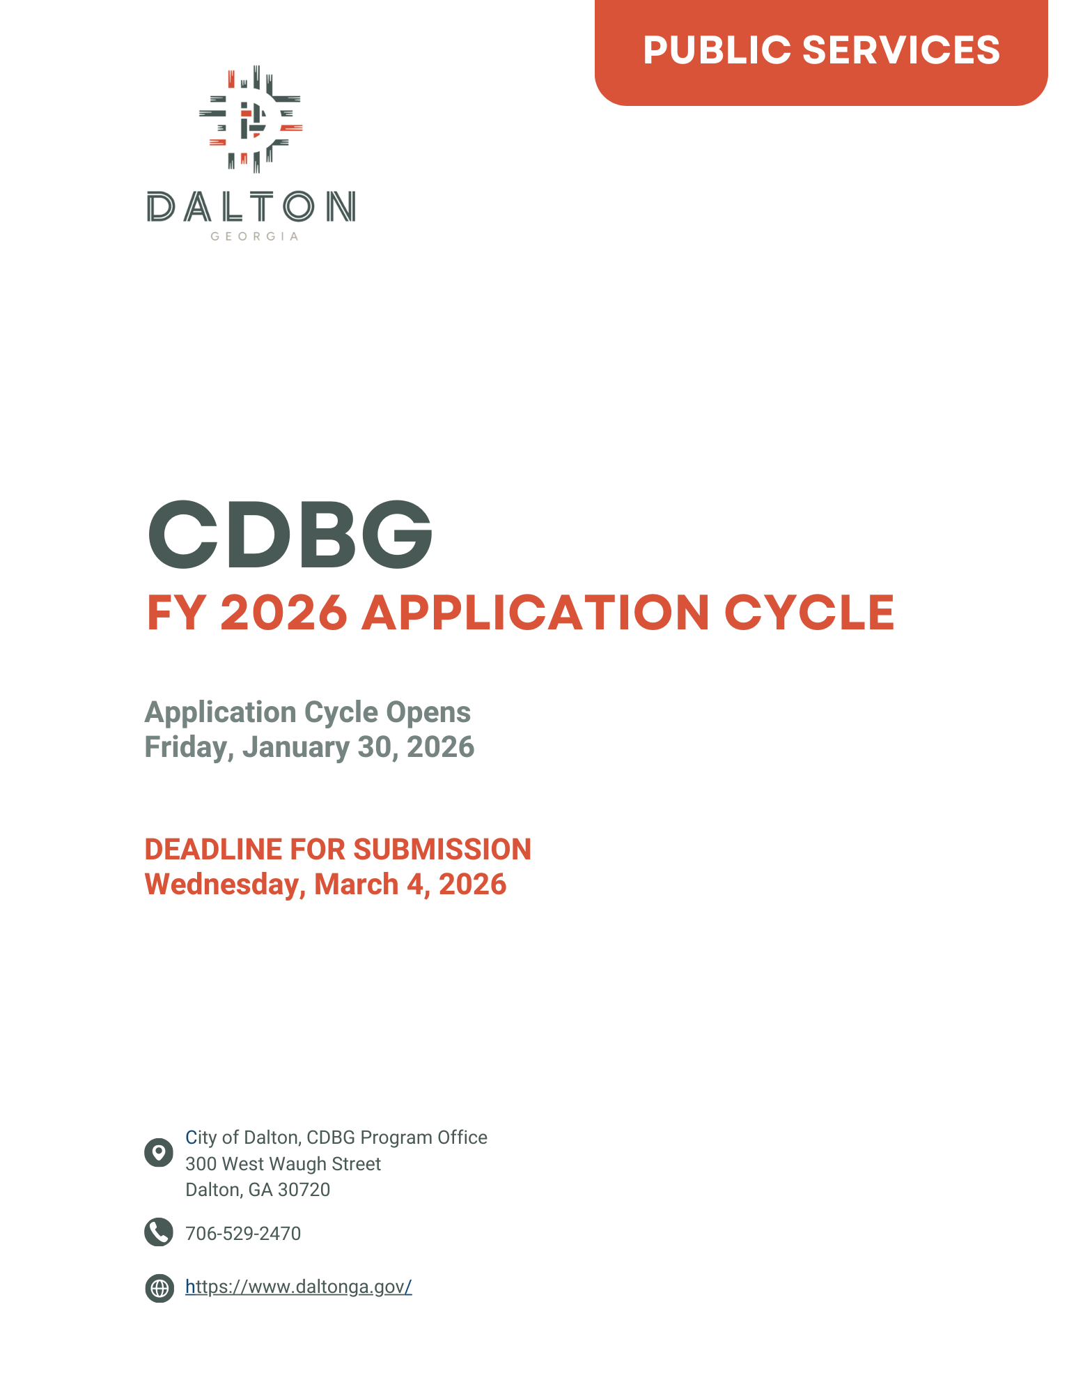

SUBMITTAL INSTRUCTIONS AND CHECKLIST
Please provide one (1) original application with attachments & one (1) application copy with attachments to the City of Dalton CDBG Program Office no later than 4:00 p.m. on Wednesday, March 4, 2026. Please label all attachments.

Submission Requirements | Documentation | Check if Enclosed
1. The applicant must  - have nonprofit status for at least one (1) full year, or  - have two (2) full years of operating experience under another nonprofit entity, or  - be a local governmental entity or agency (governmental agencies can skip to line 5) | ATTACHMENT 1:  Provide a copy of a 501(c) (3) designation letter from the Internal Revenue Service if a non-profit applicant
2. The applicant must be registered to conduct business in the State of Georgia at the time of application.  (Not applicable to governmental agencies) | ATTACHMENT 2:  Provide a copy of current certification from the GA Secretary of State. For assistance, please visit: http://sos.ga.gov/
3. The applicant must have an audit prepared by a qualified accountant or accounting service, covering the last two most recent reporting periods of operation. Copies of each audited financial statement must be submitted with the application. Reviews and Compilations will not be accepted. Open Audit findings will make the applicant ineligible to receive assistance. (Not applicable to governmental agencies) | ATTACHMENT 3:  Provide one copy each of the last two most recent audited financial statements that meet the criteria described. Include management letters if applicable.
4. Non-profit organizations must have an active Board of Directors within the last 12 months. (Not applicable to governmental agencies) | ATTACHMENT 4:  Provide list of board members and a copy of board meeting minutes authorizing the submittal of this application. Please also include a copy of Conflict of Interest Statement from the Board of Directors.
5. The applicant must have at least twelve (12) months experience directly related to the proposed project or program. | ATTACHMENT 5:  Provide funding commitments displayed on letterhead, resumes of principal staff and personnel directly working on the project, and include descriptions of the applicant’s previous related program activities.
6. The applicant must submit a written copy of its financial management procedures, including staff responsibilities and required procedures. | ATTACHMENT 6:  Provide a copy of the agency’s written financial management procedures, and a current organization chart.
7. Each applicant must submit proof of insurance for the following types of insurance: General Liability, Auto Liability, and Worker’s Compensation | ATTACHMENT 7:  Provide a copy of Certificate of Insurance.
8. Each applicant must submit proof that the organization has registered with the U.S. System for Award Management. Visit www.sam.gov | ATTACHMENT 8:  Provide proof of registration with the U.S. System for Award Management.
9. The contract period for the project, if approved, will begin July 1, 2026 and end no later than June 30, 2027. | ATTACHMENT 9:  Provide a projected timeline of proposed activities.
All submitted materials will be used in determining the organization’s eligibility for funding.

CDBG PUBLIC SERVICES PROGRAM OVERVIEW

The United States Department of Housing and Urban Development (HUD) through the Community Development Block Grant (CDBG) program provides communities with resources to address a wide range of unique community development needs. The CDBG Program provides annual grants on a formula basis to Entitlement Communities as a means to support viable communities by providing decent housing, a suitable living environment, and opportunities to expand economic opportunities, principally for low-and moderate-income persons.

The CDBG Program has three national objectives:
- Provide a direct benefit(s) to low to moderate income households
- Prevent or eliminate slum or blight
- Address an urgent need or problem within the community

Annually, the City of Dalton CDBG Program Office requests proposals from local non-profit organizations and government entities to carry out eligible activities in the City. This funding application is for the period beginning July 1, 2026 through June 30, 2027.

A Selection Committee will review all applications for compliance with requirements and make funding recommendations to the City Council. Recommendations for grant awards will be provided to the City Council during the month of May 2026.

Common CDBG Public Services activities:
Note: List is not inclusive of all eligible CDBG Public Services
- Job Training
- Child Care
- Health Care
- Fair Housing Outreach
- Services for Seniors and Homeless Persons
- Recreational and Educational Programs

In order for a project or program to qualify for CDBG funds, 51% of the program beneficiaries must be low-to moderate-income as defined by HUD. The following table reflects the current HUD income limits for one-to-eight person households who earn at or below 80% of the Area Median Income (AMI) for Dalton, GA

CDBG MAXIMUM HOUSEHOLD INCOME LIMITS [CITY OF DALTON, GA]
FY2026 Income Limits *Effective June 1, 2025

Family/ Household Size | Extremely Low  30% | Very Low-Income 50% | Low Income 80%
1 | $16,800 | $28,000 | $44,750
2 | $19,200 | $32,000 | $51,150
3 | $21,600 | $35,950 | $57,550
4 | $23,950 | $39,950 | $63,900
5 | $25,900 | $43,150 | $69,050
6 | $27,800 | $46,350 | $74,150
7 | $29,700 | $49,550 | $79,250
8 | $31,650 | $52,750 | $84,350
Source: U.S. Department of Housing and Urban Development (HUD) https://www.huduser.gov/portal/datasets/CDBG/CDBG_IncomeLmts_Natl_2024.xlsx

- AGENCY INFORMATION

Agency Name:

Mailing Address:
Telephone Number: |  |  | Email:
Contact Person: |  |  | Title:
SAM.GOV UEI Number: |  |  | Tax ID #:
- PROGRAM INFORMATION

Program Title:

Program Location:
Project Priority: | If your agency submits more than one CDBG application, please rank the priority. This project is ranked ____ of ____ CDBG project applications.

Project Type:
Funding Request Type: | ☐ New Project |  |  | ☐ Existing Project Expansion
- REQUESTED FUNDING
Total Program Cost |  |  | $
Total CDBG Amount Requested |  |  | $
Percentage of CDBG Investment (CDBG Amount Requested/ Total Program Cost) |  |  | %
- ORGANIZATION INFORMATION
- What is your organization’s mission statement?
- How long has the Organization existed in its current form?
- How long has the Organization had its 501 (c) (3) status? If your organization is a government entity, enter N/A.
- How many years has the Organization conducted the project/program for which it is requesting funding?

- ORGANIZATION CAPACITY
- What percentage of the Organization’s budget is grant funded?
- How many program staff persons are dedicated to this project (i.e. Case Managers, Intake Coordinators)?
- Does the organization have administrative staff (i.e. Accountants, Executive Director) dedicated to this grant? |  |  | Yes☐ No ☐
- Has the organization secured funding for the administrative staff for this project? |  |  | Yes☐ No ☐
- Has your agency participated in this type of activity in the past? |  |  | Yes☐ No ☐
VI. TARGET POPULATION

Briefly describe the target population/category of persons to be served in the City of Dalton (i.e. seniors, homeless, abused children, or persons with disabilities). All services must benefit low/mod clientele. For more information select the link provided. For more information select the link provided: 24 CFR 570.208
Total unduplicated persons to be served  ____________ | Total unduplicated low-Income persons to be served ____________
- PERFORMANCE OBJECTIVES & OUTCOMES
Select only one of the following objectives that best describes your project. |  | Select only one of the following outcomes that best describes your project.
☐ Suitable Living Environment |  | ☐ Improving Availability / Accessibility
☐ Decent Housing |  | ☐ Improving Affordability
☐ Creating Economic Opportunity |  | ☐ Improving Sustainability

- NARRATIVE

Limited Clientele Criteria: If proposing a public services activity under the Limited Clientele Criteria in which the service will benefit a specific group primarily presumed to be low and moderate income, such as abused children, battered spouses, elderly persons, severely disabled adults, homeless persons, illiterate adults, persons living with AIDS, and migrant farm workers of persons or serve at least 51 percent low and moderate income persons, answer the following question.
- Please provide a description of the proposed project for funding.

- The City will require organizations to submit monthly reports pertaining to expenditure of CDBG-funded activities. Describe and discuss any experiences you have in reporting, monitoring, and/or record-keeping compliance requirements with CDBG and other funding agencies.

- Describe the need for the proposed program/project within the community and provide data that supports this need. Where will the program/activity be completed or carried out?

- Describe the services/activities to be provided or completed and estimate the number of persons to be assisted with CDBG funding. Persons to be assisted should be described in terms of race, ethnicity, and income level. Include any necessary data to support the clientele who will benefit from the program/project. At least 51% of clients served with CDBG funding must be LMI (low and moderate income
- Please describe your organization’s method for determining income eligibility.

BUDGET INFORMATION
(For Service/Operational Costs)
- BUDGET PROPOSAL
Complete the following budget template:
Line Items | CDBG Funds | Other Funds | Total Funds
Staff Salaries | $ | $ | $
Staff Fringe Benefits | $ | $ | $
Staff Travel | $ | $ | $
Office/Program Communications | $ | $ | $
Office/Program Rental/Lease | $ | $ | $
Office/Program Utilities | $ | $ | $
Equipment Purchase | $ | $ | $
Office/Program Materials/Supplies | $ | $ | $
Insurance/Bonding | $ | $ | $
Contractual Services | $ | $ | $
Direct Client Cost | $ | $ | $
Printing and Reproduction | $ | $ | $
Audit
GRAND TOTAL | $ | $ | $

BUDGET PROPOSAL NARRATIVE
1. For each line item listed in your budget, provide a detailed description of how CDBG funds will be used to support your program.
2. Please provide the source and amount of funding commitments, as well as additional funding awarded in the past three years for this project.

- CONFLICT OF INTEREST ACKNOWLEDGEMENT
Do any family relationships (by blood or marriage) exist between staff in your organization and/or Agency Board members?
Yes ☐ No ☐
If yes, please explain in detail and document the staff person’s involvement with these grant funds in the section below.
Do any family relationships (by blood or marriage) exist between staff in your organization and/or the Dalton City Council?
Yes ☐ No ☐
If yes, please explain in detail and document the staff person’s involvement with these grant funds in the section below.
ACKNOWLEDGED RESPONSIBILITY TO ABIDE BY ALL HUD AND CITY OF DALTON REQUIREMENTS
The applicant agrees to abide by all policies, regulations, ordinances, or statutes as required by HUD and City of Dalton. Please select the following link to comprehensively review the CDBG regulations: 24 CFR 570.
Yes ☐ No ☐
CERTIFICATION
I certify that the applicant agency meets the conditions specified in the application instructions and will be able to carry out the proposed services in concert with all federal requirements. I also certify that the organization is a certified IRS 501(c) (3) non-profit or governmental agency. I agree to adhere to the above provisions for all programs receiving assistance from the US Department of Housing & Urban Development. All board and staff members have disclosed any potential conflicts of interests that could violate CDBG Program regulations at this time or at a later date. I further certify that I have reviewed the contents of this application and the rating form and deem them to be accurate and true.

Federal Suspension and Debarment Certification:
Federal Executive Order 12549 prohibits federal, state, and local public agencies receiving grant funding from contracting with individuals, organizations, or companies who have been excluded from participating in federal contracts or grants. The purpose of this certification is for the contractor/vendor to advise the City of Dalton, in writing, of any current Federal Suspension and Debarment.

Debarment Certification. By signing and submitting a response to this competitive solicitation, I certify that this firm and its principals are not currently suspended or debarred by any Federal Department or Agency from participating in Federal Funded Contracts.
Authorized Representative
Signature: Printed Name:
Printed Name: Title:

Attach job descriptions of all staff members to be paid under this project.
All projects must have annual independent audit. Agencies with federal or federally-derived funded expenditures of $750,000 or more must have an annual A-133 audit. Cost of conducting this audit is an eligible CDBG expense.

